GATE 0 – PROJECT SYNOPSIS
Themes 1–5 | System / Tool / Engine-based Mini Projects
Prepared from Team 08 Stage S1 presentation material; organized using the supplied Gate 0 synopsis structure.
Field | Details
Team No. | 08
Theme No. | System / Tool / Engine-based Mini Project (specific theme number not stated)
Project Title | Large-Scale Dataset Profiling & Data Quality Engine
Guide Name | Ms. Sneha Varur
Team Members | Anupriya Savant (01FE24BCI046); Pavitra Jalibenchi (01FE24BCI049); Anushree Angadi (01FE24BCI050); Sahana Awaradi (01FE24BCI030)

1. Motivation
Structured datasets can contain missing values, duplicate records, inconsistent types, invalid values, and statistically unusual observations. The proposed project brings dataset profiling and data-quality assessment into a single workflow so users can inspect a dataset, identify quality issues, select supported corrections, and revalidate the results. The presentations describe an upload-to-report workflow and emphasize preserving the original dataset while applying corrections to a separate copy.
The project draws on DBMS, Data Structures and Algorithm Analysis, Probability and Statistics, Machine Learning concepts, Operating Systems, and Web Technologies.

2. Project Objectives
- To accept supported structured/tabular datasets and generate a structural profile.
- To identify missing values, duplicate rows, data-type inconsistencies, and rule violations.
- To compute descriptive statistics and flag potentially unusual observations.
- To allow users to review detected issues and apply selected supported corrections without changing the original dataset.
- To revalidate corrected data and present data-quality results and reports.

FOUNDATION COURSE INTEGRATION & CONCEPTUAL VIEW

3. Foundation Course Integration
Sl. No. | Foundation Course | Broad Concepts / Areas Expected to Be Applied | Role
1 | Database Management Systems | Dataset structure, schema, data types, consistency, storage and retrieval | Dominant (inferred from presentation emphasis)
2 | Data Structures & Algorithm Analysis | Scanning, comparison/hashing for duplicate detection, efficient data processing | Dominant (inferred)
3 | Probability & Statistics | Descriptive statistics, distributions, missing-value rates, IQR-based outlier screening | Dominant (inferred)
4 | Machine Learning | Anomaly-analysis concepts and interpretation of unusual observations | Supporting (inferred)
5 | Operating Systems | Files, memory, processing and resource limits | Supporting (inferred)
6 | Web Technologies | Dataset upload, dashboard, user interactions and reporting | Supporting (inferred)

4. Conceptual Workflow / System View
Input | Assessment | User action | Output
Upload structured dataset | Profile → detect issues → analyze statistical patterns | Select issues → apply supported corrections → revalidate | Quality score and report

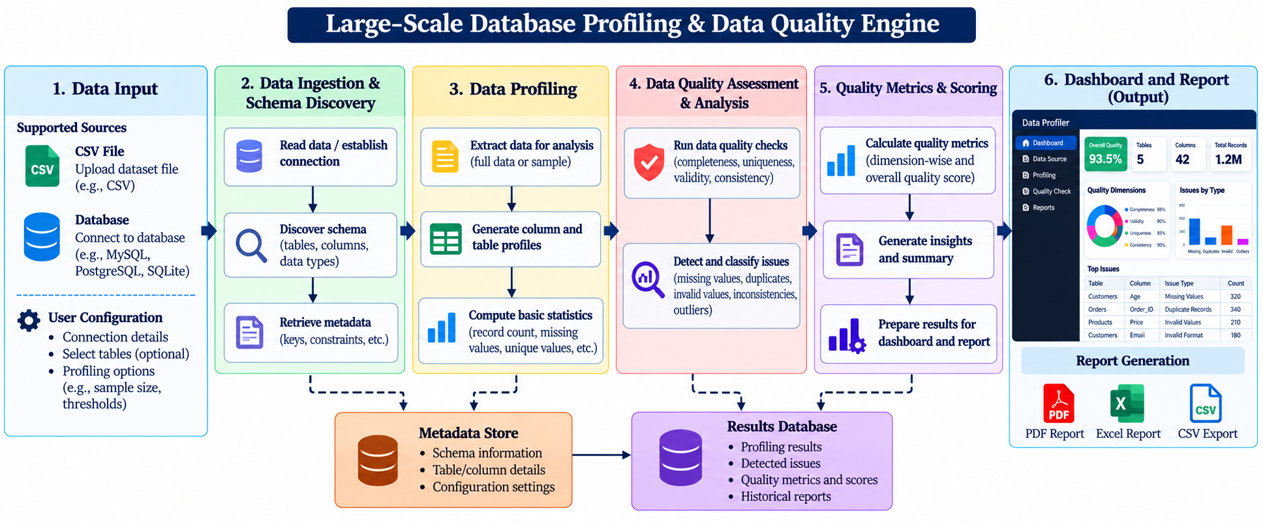

Engine | Conceptual responsibility
E1 – Dataset Profiling | Summarize rows, columns, types and basic characteristics
E2 – Completeness & Duplicate Detection | Identify missing values and exact duplicate rows
E3 – Data Validation & Consistency | Check configured formats, allowed values and constraints
E4 – Statistical & Anomaly Analysis | Summarize numeric distributions and flag potential outliers

5. Broad Project Scope

5.1 Broadly In Scope
# | Broad In-Scope Item
1 | Upload and inspect supported structured/tabular datasets.
2 | Profile datasets and detect missing, duplicate, inconsistent and invalid values.
3 | Perform basic statistical analysis and flag possible outliers.
4 | Display findings, allow selected supported corrections, revalidate, and produce quality results.

5.2 Out of Scope
# | Out-of-Scope Item | Reason / boundary in source
1 | Enterprise-scale deployment | Beyond initial student project and resource scope
2 | Real-time enterprise monitoring | Excluded from initial integration scope
3 | Support for every database/cloud platform or input format | Limited supported structured/tabular formats and integrations

6. Feasibility & Constraints
Aspect | Assessment from presentations
Feasibility within 3-credit scope | A 15-week semester and limited student development resources are identified; a formal 3-credit feasibility conclusion is not provided.
Required computing / resources | Dataset processing requires local file handling, memory and storage; exact equipment specifications are not stated.
Prerequisite knowledge | DBMS, DAA, Probability & Statistics, Machine Learning concepts, OS and Web Technologies.
Major constraints / limitations | Limited supported input formats; memory/storage demands for larger datasets; supported corrections only; original data must remain unchanged.
Use of existing libraries / tools | Not explicitly specified in the slides.
Overall feasibility | Not explicitly assessed in the slides; requires faculty confirmation.

